BSCS FINAL PROJECT
<Requirements Specification>

“Real-Time Predictive & Descriptive Analysis in HealthCare”



Project Advisor

ASIF FAROOQ

Presented by:
Group ID: F23CS034

Student Reg# Registration ID

SHAHZAIB KHAN L1F20BSCS0230@ucp.edu.pk
SYED MUHAMMAD AMER ALI ZAIDI L1F20BSCS0215@ucp.edu.pk
SAAD ANJUM KHAN L1F20BSCS0229@ucp.edu.pk

Faculty of Information Technology

University of Central Punjab
Software Requirements Specification
Version 1
Real-Time Predictive & Descriptive Analysis in HealthCare
Advisor: Asif Farooq

Group F23CS034
Member Name | Primary Responsibility
Shahzaib Khan | Front-End & Back-End
Syed Muhammad Amer Ali Zaidi | Front-End & Back-End
Saad Anjum Khan | Front-End & Documentation

Table of Contents
Table of Contents i
Revision History iii
Abstract 4
1. Introduction and Background 5
1.1 Product (Problem Statement) 5
1.2 Background 5
1.3 Scope 5
1.4 Objective(s)/Aim(s)/Target(s) 6
1.5 Challenges 6
1.6 Learning Outcomes 6
1.7 Nature of End Product 7
1.8 Completeness Criteria 7
1.9 Business Goals 7
1.10 Related Work/ Literature Survey/ Literature Review 8
1.10.1 Real-Time Analytics 8
1.10.2 Predictive Analytics 8
1.11 Document Conventions 9
2. Overall Description 9
2.1 Product Features 9
2.1.1 Real-Time Predictive Analytics 9
2.1.2 Web Portal 9
2.1.3 Drill-Down Analysis 9
2.1.4 Data Visualization 9
2.2 User Classes and Characteristics 10
2.3 Operating Environment 10
2.4 Design and Implementation Constraints 11
2.5 Assumptions and Dependencies 11
2.5.1 Assumptions 11
2.5.2 Dependencies 11
3. Functional Requirements 12
3.1 Manage Account 13
3.2 Manage Area 14
3.3 Login to System 16
3.4 Log Out 16
3.5 Upload Medical Record 17
3.6 View Results of Predictive Model 18
3.7 Real-Time Analytics on Dashboard 19
3.8 Requirements Analysis and Modeling 19
3.8.1 Use Case Diagram 19
3.8.2 Entity-Relationship Diagram 20
3.8.3 Sequence Diagram 21
3.8.4 Abstract Class Diagram 24
4. Nonfunctional Requirements 24
4.1 Performance Requirements 24
4.2 Safety Requirements 24
4.3 Security Requirements 25
4.4 Additional Software Quality Attributes 25
4.4.1 Reliability 25
4.4.2 Availability 25
4.4.3 Security 25
4.4.4 Usability 25
5. Other Requirements 25
5.1 Hardware And Software Requirements 25
5.1.1 Hardware Requirements 25
5.1.2 Software Requirements 26
6. Revised Project Plan 26
7. References 26

Revision History
Name | Date | Reason For Changes | Version

Abstract
The project aims to make a scalable and real-time healthcare analytics system. The system will utilize the generic data format based on patient demographics to predict the spread of viral disease. Later on, it could be expanded to utilize clinical data as well as environmental data to make the prediction more robust. To facilitate data analysis and visualization, we will create a role-based secure web portal for hospitals and medical centers to gather data and analyze. This web portal will be a powerful descriptive and predictive analytical dashboard through interactive graphs and models. The system will provide summaries, drill-down views, and data filtering to analyze disease trends. It will empower health authorities to make well-informed decisions and take proactive measures to safeguard public health effectively.

Introduction and Background
Viral and Infectious diseases are a major threat to public health, and the rapid spread of these diseases is a challenge in the modern world. Timely and accurate data analysis is crucial to understanding and taking action against these diseases, but conventional data collection and analysis processes can be slow and expensive. This can delay decision-making against these diseases, and because of this we lose lives.

This project aims to develop a scalable and real-time predictive and descriptive analytics system to address this issue. The goal is to provide healthcare associations and governmental bodies with a powerful tool for monitoring streaming analytics through graphs and machine learning. This will significantly improve the early detection of disease epidemics within Pakistan and other countries, empowering the government to take quick action against deadly diseases.

Product (Problem Statement)
Whenever a disease spreads, a substantial amount of time and resources are consumed in the data collection and analysis of its root cause(s), resulting in a delay in taking reactive steps to control it. This delay, when elongated, can cost a lot of precious lives. Many lives can be saved by taking adequate steps at the right time. We will be developing a system that will provide real-time analytics to healthcare associations so that proactive steps can be taken to control an epidemic and scale down casualties.

Background
Our project aims to create a web portal dedicated to healthcare data analysis. The domain of this project focuses on the field of big data analytics, with a specific focus on the healthcare sector. In today's world, viral and infectious diseases are a significant threat to public health and their rapid spread presents a major challenge.
The problem that is addressed by the project is the time and resources needed for collecting data and performing analysis in healthcare sectors. These traditional approaches often cause delays in decision-making toward disease outbreaks, resulting in the loss of mankind's lives. To combat this, the web portal will serve as a powerful tool to analyze large amounts of healthcare data in real-time by using interactive graphs, charts, models and machine learning algorithm to enhance the early detection of disease outbreaks. By integrating predictive and descriptive analytics, the portal will provide healthcare and governmental bodies with critical insights, enabling them to respond swiftly and effectively to public health crises.

Scope
- Working on a disease for analysis in a peculiar region.
- Developing a web portal for presenting streaming descriptive and predictive analytics.
- Analyzing input data received from different healthcare sectors.
- Exploring different predictive models to get the best model for prediction.
- Customize analytics and reports for various administrative levels such as the provinces, districts, tehsils, and hospitals, handling specific needs and end-user roles.

Objective(s)/Aim(s)/Target(s)
In our project, the following are the objectives we want to achieve:
- Our goal is to help the Government to control the disease spread and the resulting death rate in Pakistan.
- To improvise the system for early disease epidemic detection in Pakistan by creating a predictive model using a machine learning algorithm.
- Develop a system for government and health organizations to track health analytics through graphs and models, providing clear reports and visualizations for informed decision-making.

Challenges
- Selecting an appropriate Machine Learning algorithm for our prediction system.
- Combining various technologies like Apache Kafka, Apache Spark, and MLlib into a seamless data pipeline.
- Managing and processing streaming data efficiently in real-time.
- Designing a system that can scale to handle large amounts of data and users as the user base grows.
- Implementing a secure and robust role-based authentication system for different user levels.
- Designing a better UI/UX interface for easier data visualization.
- Developing RESTful APIs for data retrieval and ensuring they integrate well with the front end.
- Building a system in such a way that it performs well under heavy usage and is optimized for quick data retrieval and analysis.

Learning Outcomes
After completion of the Project, we will be familiar with the following technologies:
- Apache Kafka
- Apache Spark
- MLlib
- Java Spring Boot
- Rest API Building
- PostgreSQL
- React
- JavaScript
- Apache E-Charts
- Scala
After completion of the Project, we will be familiar with
- Machine Learning
- Data Engineering
- Web Application Development

We will learn Apache Kafka for streaming data to the Postgres database and Apache Spark Streaming to store data into RDDs (Resilient Distributed Datasets). Also, Spark MLlib for the predictive model and store the prediction result in Postgres. We will also be learning how to create REST API in Java using Spring Framework which will be used for managing user profiles and preferences and fetches analytical data. For the front-end side, we will learn React to build a better UI/UX and Apache E-Charts for data visualization.

Nature of End Product
End product will be a scalable and real-time healthcare analytics system which will utilize the generic data format to predict viral disease spreading. This system will facilitate data analysis and visualization, a role-based secure web portal for hospitals and medical centers to gather and analyze data. The system will provide summaries, drill-down views, and data filtering to analyze disease trends. It will empower health authorities to make well-informed decisions and take proactive measures to safeguard public health effectively.

Completeness Criteria
Following are the completeness criteria that will ensure the completion of the project:

S.No. | Criteria | Weightage %
1 | Web App Development | 30
2 | Machine Learning | 20
3 | Data Pipeline | 30
4 | Documentation | 10
5 | Data Visualization | 10

Business Goals
This software aims to achieve the following business goals:
- Use real-time predictive and descriptive data analysis to identify potential issues early and make informed decisions that lead to better patient outcomes.
- Improve public healthcare by enabling proactive measures against disease outbreaks and reducing the financial burden on healthcare systems.
- Drive advancements in medical research by offering valuable insights to improve patient outcomes through comprehensive analytics and predictive models.
- Adhere to strict ethical guidelines and regulations to protect patient privacy and sensitive information.
- Establish transparency and responsible data usage to build trust with healthcare professionals and institutions.
- Create a scalable solution adaptable to increasing data volumes and evolving healthcare scenarios.

Related Work/ Literature Survey/ Literature Review
This project has been categorized into two parts. The first part will cover the real-time analysis of healthcare data, whereas the second part focuses on analyzing the dataset to give predictive analysis to take measures for stopping the spread of the disease.

Real-Time Analytics
Through our study of already developed real-time analytics on big data we found out that researchers from around the world have been working on designing different solutions for healthcare. Following are some related work and research done by different foundations and organizations:

Research done by Antony Basco J. and Senthilkumar N.C at VIT University showed how big data analytics can be used to provide better treatment opportunities. Their proposed framework was meant to be used by doctors to predict and cure the disease at initial stages. For this purpose, it uses Electronic Medical Records (EMR). It stores all the medical data in HDFS. The system takes EMR as an input in NOSQL format and performs similarities between input data and data stores in HDFS. Every time a new record is entered, the map outputs a predictive result for the patients. At the same time, it also inserts the newly entered records into already stored data. These results were then used by doctors to prescribe the proper medication to cure a disease at an early stage.[1]
Furthermore, the research paper written by Wullianallur Raghupathi and Viju Raghupathi outlines the potential of big data analytics in solving the problem of healthcare. This paper shows how health and medical data is a good use case of big data by mapping the 4 V's of big data to health data. Moreover, how these analytics can be advantageous in this field including research. Finally, it outlines some possible challenges that one might incur while implementing big data solutions for different healthcare applications.[2]
In addition, IBM and some other firms have been using real-time analytics to improve healthcare. Those platform(s) include continuous monitoring of patient’s health using different sensors and providing the doctor with real-time reports of their patients so that they can provide proactive treatment to their patients. [3]

Predictive Analytics
We went through different research papers, but the research done by MD Saiful Islam et al. categorized all the classification models that have been used in the research publications dated from 2004 to 2016. According to this research, algorithms like Logistical regression, Bayesian Network, Decision Trees, Artificial Neural Networks, Fuzzy-based algorithms, and Support vector machines were most frequently used in different classification problems.
This research further showed that apart from the above k-means and self-organizing maps are the two algorithms that are found to be most frequently applied in healthcare-related problems. This research article concluded that performance varies on every dataset.[4]

Document Conventions
Font:
- Times New Roman font is used throughout the document.
Line Spacing:
- 1.5 line spacing is used throughout the document.
Heading Style
- Heading 1: Font size 18.
- Heading 2: Font size 14.
- Heading 3: Font size 12.
Normal Text Font Size:
- Normal text font size 12.

Overall Description

Product Features
The project encompasses major features to revolutionize healthcare data analytics and disease management. These features include:

Real-Time Predictive Analytics
Utilizing machine learning algorithms, the system predicts upcoming patients of the disease outbreak, which enable government body to take early action and measures against disease outbreak,

Web Portal
A role-based web portal is provided for government officials and hospitals to securely access and analyze healthcare data.

Drill-Down Analysis
Users can drill down into data to explore details, identify potential hotspots, and investigate the root causes of disease outbreaks.

Data Visualization
Web Portal Dashboard will use different graphs, charts, and models, allowing users to gain insights into disease trends.

User Classes and Characteristics
Super Administrator:
- Overall Real-time Analytics Report of every Hospital through the web portal dashboard with filter options.
- View Predictive Analytics of a specific hospital or all hospitals under the Tehsil, District, and Province.
- Super Administrator will be responsible for creating, editing, and deleting accounts/areas.
- Super Administrator can upload medical data for any hospital.
Province Administrator:
- Province Administrators can view real-time analytics reports for hospitals within their Province through the web portal dashboard with filter options.
- View Predictive Analytics of a specific hospital, or all hospitals under that province.
- Province Administrator can upload medical data of any hospital falling under its province.
District Administrator:
- District Administrators can view real-time analytics reports for hospitals within their District through the web portal dashboard with filter options.
- View predictive analytics for specific hospitals or all hospitals within their district.
- District Administrator can upload medical data of any hospital within their district.
Tehsil Administrator:
- Tehsil Administrators can view real-time analytics reports for hospitals within their Tehsil through the web portal dashboard with filter options.
- View predictive analytics for specific hospitals or all hospitals within their Tehsil.
- Tehsil Administrators can upload medical data for hospitals that fall under their Tehsil.
Hospital Administrator:
- Hospital Administrators can view real-time analytics reports of their respective hospitals through the web portal dashboard with filter options.
- View Predictive Analytics of Hospital.
- Hospital Administrator can only upload medical data of their respective hospital.

Operating Environment
The software will operate in an environment optimized for better performance. The hardware side will consist of machines containing 16 GB RAM, an Intel i5/i7/i9 8th generation or above processor or a similar processor, a dedicated GPU for machine learning, and a server that should be available 24/7. The operating system should be an updated version of Windows 10/11 or a Linux-based operating System. On the other hand, in software, the environment will include the latest stable releases of NodeJS, Apache Spark, Apache Kafka, Scala, ZooKeeper PostgreSQL, Scala, and Java Development Kit (JDK). The web portal will be designed to function across all major browsers, including Chrome, Firefox, Safari, and other web browsers to ensure no end-user is limited by their choice of machine.

Design and Implementation Constraints
Following are the design and implementation constraints below:
- Designing a user-friendly interface that can efficiently present complex data analytics.
- Development machines must meet the hardware specifications, including a minimum of 16 GB RAM, an Intel i5/i7/i9 8th generation processor or above (or equivalent), and a capable GPU suitable for machine learning tasks.
- Design RESTful APIs following the best practices, including proper HTTP methods and status codes.
- Proper commenting and using descriptive naming conventions for variables and functions in development to convey the purpose to ensure the system's quality.
- Utilizing the documentation of frameworks, tools, and libraries to gain insights into the best practices, troubleshoot issues, and harness the full potential of these tools during the development.

Assumptions and Dependencies
We have taken the assumptions and dependencies below for the development of this system:

Assumptions
- The data provided by the hospitals are clean, accurate, and ready for analysis without needing pre-processing.
- The users have a fast and reliable working internet connection to access the web portal effectively.
- The users have a compatible latest web browser that supports our web portal.
- Super administrator has a user account created with all administrative privileges.

Dependencies
- The server requires a 24/7 online server capable of supporting Big Data technologies like Apache Spark and Kafka. This server infrastructure is vital for deploying and running the healthcare analytics system.
- Users of the system, particularly those involved in data analysis, are expected to have sufficient technical knowledge to analyze and interpret results present on the web portal dashboard in the form of graphs, charts, and models.
- Regular updates and maintenance of the software environment, including Big Data technologies and the web portal, for uninterrupted service.

Functional Requirements

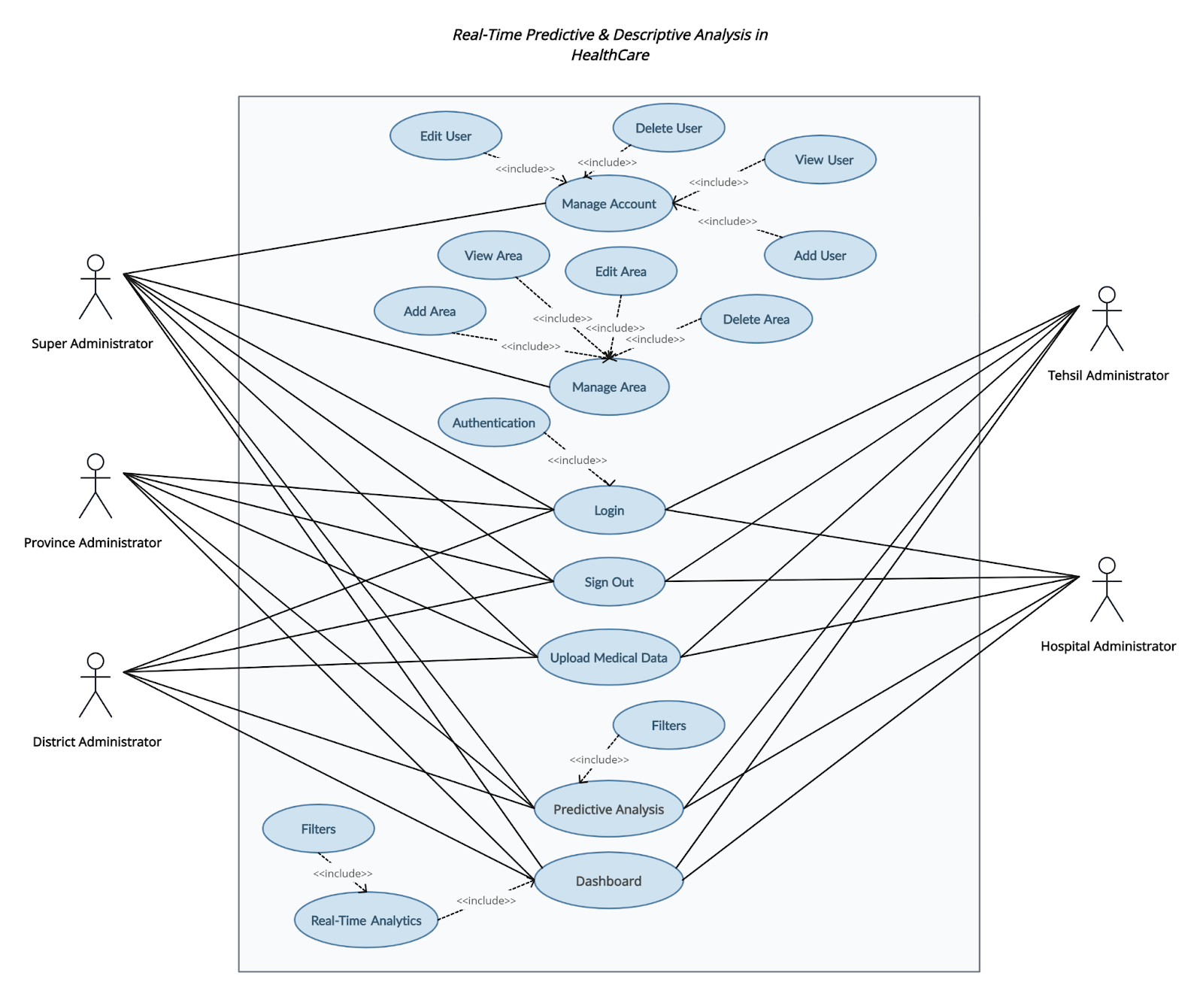

Figure 3.1: Use-Case Diagram

Manage Account
Identifier |  | UC-1
Purpose |  | View/Add/Delete/Edit User Accounts in the System
Priority |  | High
Pre-conditions |  | Super Administrator must already login to the system
Post-conditions |  | Account successfully viewed/added/deleted/edited account
Typical Course of Action
S# | Actor Action | System Response
1 | Navigate to the Manage Accounts | System Display the Manage Accounts Page
2 |  | Display Add User Button, Table View of User with Edit and Remove Button
Alternate Course of Action (Add)
S# | Actor Action | System Response
1 | Navigate to the Manage Accounts | System Display the Manage Accounts Page
2 |  | Display Add User Button, Table View of User with Edit and Remove Button
3 | Click Add User | Select User Type
4 |  | Fill Details and Press Button to confirm to add the user in the system.
5 |  | If Adding User is successful, the system displays a confirmation message: “User added successfully”
Alternate Course of Action (Edit)
S# | Actor Action | System Response
1 | Navigate to the Manage Accounts | System Display the Manage Accounts Page
2 |  | Display Add User Button, Table View of User with Edit and Remove Button
3 | Click Edit Button for a User from the Users Table
4 |  | Edit User Details and Press Button to confirm editing the user details.
5 |  | If Editing User details is successful, the system displays a confirmation message: 'User Details edited successfully'
Alternate Course of Action (Delete)
S# | Actor Action | System Response
1 | Navigate to the Manage Accounts | System Display the Manage Accounts Page
2 |  | Display Add User Button, Table View of User with Edit and Remove Button
3 | Press Delete button for deleting a User Account from the Users Table | If User is deleted successfully from the system, the system displays a confirmation message: “User Details edited successfully”
Table 1: UC-1

Manage Area
Identifier |  | UC-2
Purpose |  | View/Add/Delete/Edit Area in the System
Priority |  | High
Pre-conditions |  | Super Administrator must already login to the system
Post-conditions |  | Area successfully viewed/added/deleted/edited
Typical Course of Action
S# | Actor Action | System Response
1 | Navigate to the Manage Area | System Display the Manage Area Page
2 |  | Display Add Area Button, Table View of Area with Edit and Remove Button
Alternate Course of Action (Add)
S# | Actor Action | System Response
1 | Navigate to the Manage Area | System Display the Manage Area Page
2 |  | Display Add Area Button, Table View of Area with Edit and Remove Button
3 | Click Add Area
4 |  | Fill Details and Press Button to confirm to add the area in the system.
5 |  | If the Adding Area is successful, the system displays a confirmation message: “Area added successfully.”
Alternate Course of Action (Edit)
S# | Actor Action | System Response
1 | Navigate to the Manage Area | System Display the Manage Area Page
2 |  | Display Add Area Button, Table View of Areas with Edit and Remove Button
3 | Click Edit Button for Area from the Area Table
4 |  | Edit Area Details and Press Button to confirm editing the area details.
5 |  | If Editing area details is successful, the system displays a confirmation message: “Area Details edited successfully”
Alternate Course of Action (Delete)
S# | Actor Action | System Response
1 | Navigate to the Manage Area | System Display the Manage Area Page
2 |  | Display Add Area Button, Table View of Areas with Edit and Remove Button
3 | Press Delete button for deleting an Area Account from the Area Table | If the Area is deleted successfully from the system, the system displays a confirmation message:” Area Details deleted successfully”
Table 2: UC-2

Login to System
Identifier |  | UC-3
Purpose |  | Login to Get Access to Dashboard
Priority |  | High
Pre-conditions |  | User has an already account in the system
Post-conditions |  | User has successfully login in the system
Typical Course of Action
S# | Actor Action | System Response
1 |  | Shows the login form.
2 | Enters his/her email id and password in the login form
3 | Click on the Login Button | Verifies user credentials. If valid, redirect the user to the Dashboard Page of the web portal.
Alternate Course of Action
S# | Actor Action | System Response
1 | Enters his/her email ID or password in the login form
2 | Click on the Login Button | If credentials are invalid, it displays an error message:  “Email or Password is incorrect”
3 |  | Go to step 1.
Table 3: UC-3

Log Out
Identifier |  | UC-4
Purpose |  | To Logout from the system
Priority |  | Low
Pre-conditions |  | User must already be login to the system.
Post-conditions |  | User has successfully logged out.
Typical Course of Action
S# | Actor Action | System Response
1 | Press the Account Menu button present on the top right corner of the web portal | A pop-up menu will show up, showing different options.
2 | User Click “Log out” Button | User has successfully logged out
3 |  | Go to UC-1
Table 4: UC-4

Upload Medical Record
Identifier |  | UC-5
Purpose |  | Upload Medical Record into system
Priority |  | High
Pre-conditions |  | User must already login to the system
Post-conditions |  | Medical Record successfully uploaded
Typical Course of Action
S# | Actor Action | System Response
1 | Navigate to the Upload Medical Records | System Display the Upload Medical Records
2 | Select Hospital
3 | Click the 'Browse/Upload' button to select a file. | System Open file selection dialog (File Explorer)
4 | Select the CSV file containing medical data and Click ‘Open’ | If the upload is successful, then the system displays a confirmation message: “File uploaded successfully”
5 |  | System redirects to the Dashboard of web portal
Alternate Course of Action
S# | Actor Action | System Response
1 |  | If upload fails, then the system displays an error message:” File uploading failed!”
2 |  | System redirects to step 1 of the Typical Course of Action to allow the user to try uploading again.
Table 5: UC-5

View Results of Predictive Model
Identifier |  | UC-6
Purpose |  | View and Analyze results presented by the Predictive Model
Priority |  | Medium
Pre-conditions |  | Users need to be already login to the system
Post-conditions |  | User has viewed the results of predictive model
Typical Course of Action
S# | Actor Action | System Response
1 | Navigate to the Predictive Analysis | System Display the Predictive Analysis Page
2 |  | Display Predictive Analysis
Alternate Course of Action
S# | Actor Action | System Response
1 | Select Options from Filters | Display Update Predictive Analysis
Table 6: UC-5

Real-Time Analytics on Dashboard
Identifier |  | UC-7
Purpose |  | Real-time analytics on the dashboard upon login
Priority |  | High
Pre-conditions |  | User must already be login to the system and medical data should be already uploaded in the system.
Post-conditions |  | User is shown real-time analytics on the dashboard
Typical Course of Action
S# | Actor Action | System Response
1 | User Login to the System | System authenticates the user.
2 |  | System Redirect to Default Dashboard containing Real-Time analytics
Alternate Course of Action
S# | Actor Action | System Response
1 | Select Options from Filters | Display Updated Dashboard containing Real-Time analytics
Table 7: UC-7

Requirements Analysis and Modeling

Use Case Diagram
Provided in the Functional Requirement part.

Entity-Relationship Diagram

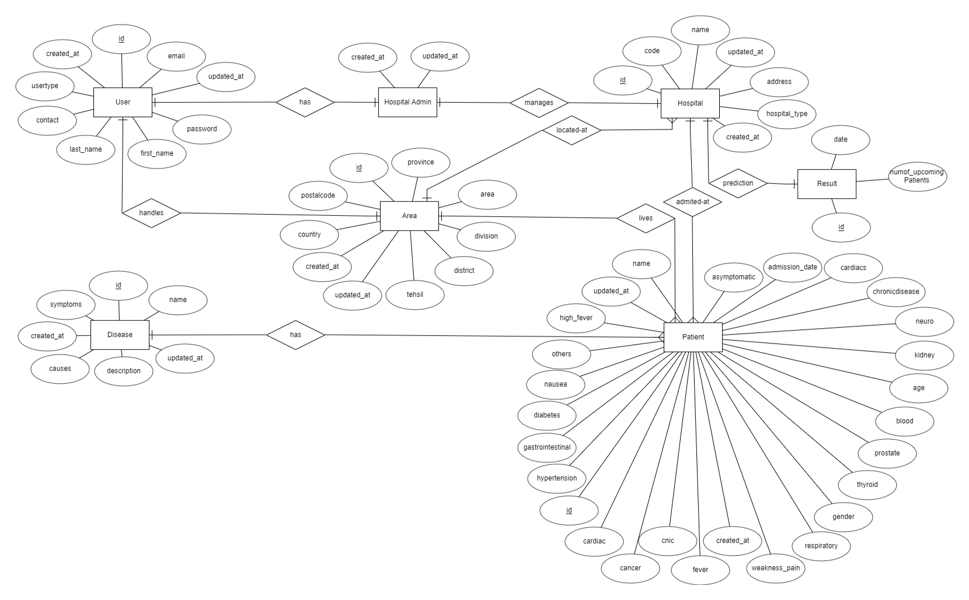

Figure 3.8.2.1: Entity-Relationship Diagram

Sequence Diagram
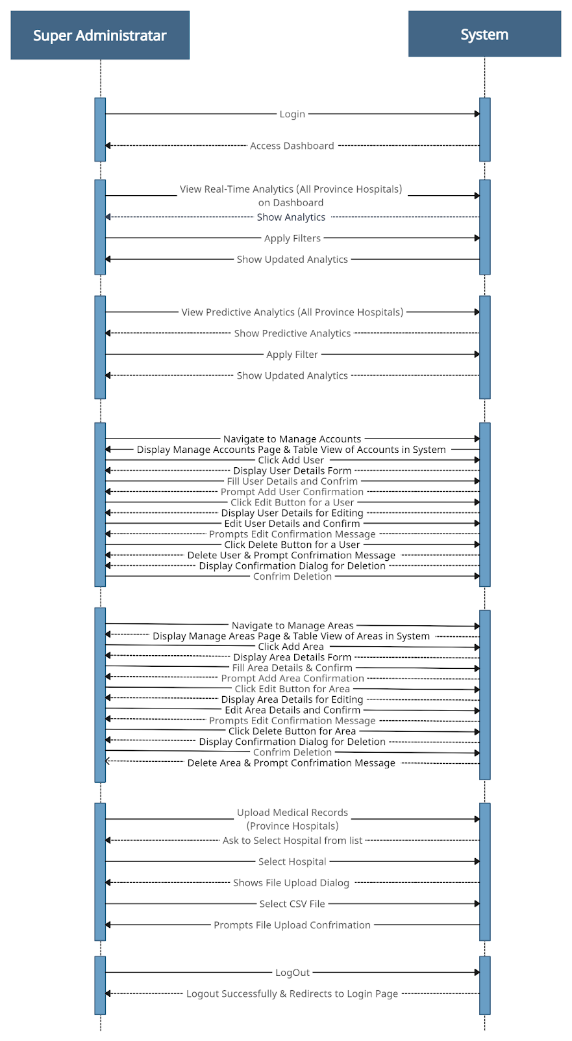
Figure 3.8.3.1: Super Administrator Sequence Diagram

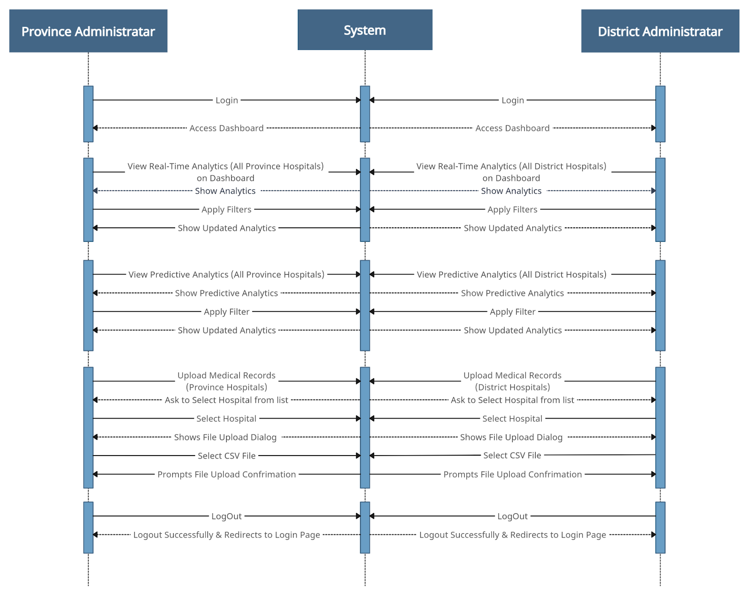

Figure 3.8.3.2: Province and District Administrator Sequence Diagram

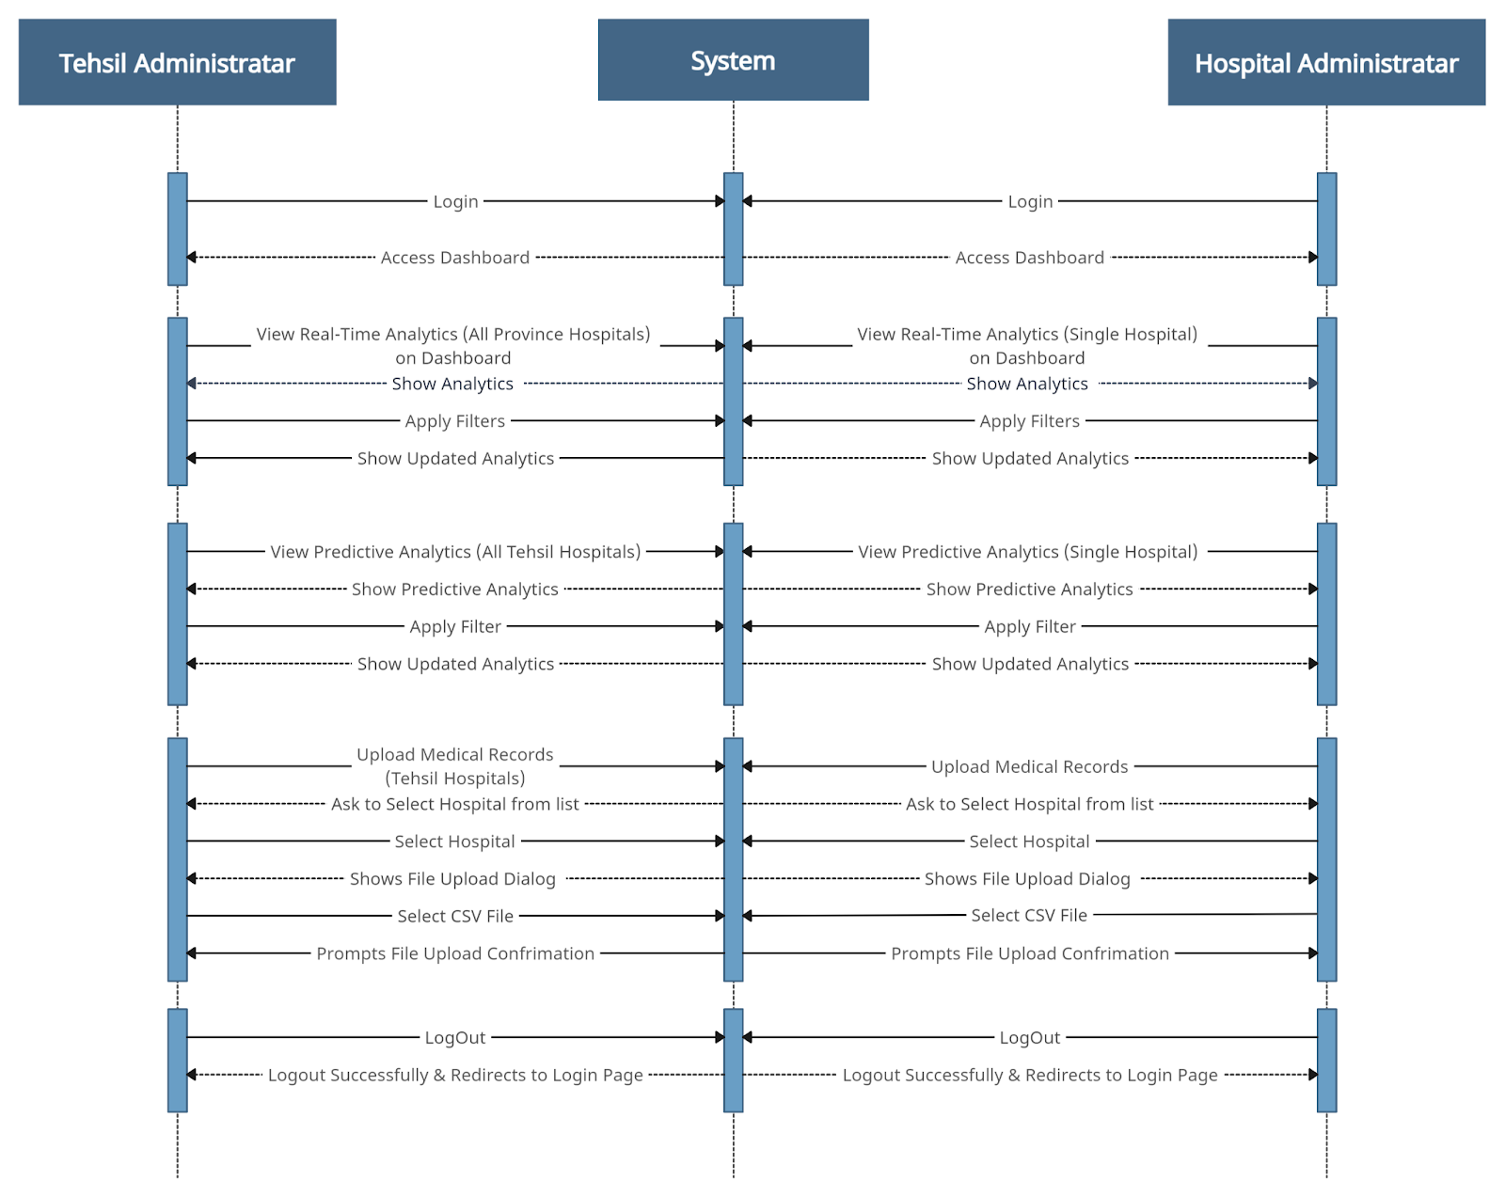

Figure 3.8.3.3: Tehsil and Hospital Administrator Sequence Diagram

Abstract Class Diagram
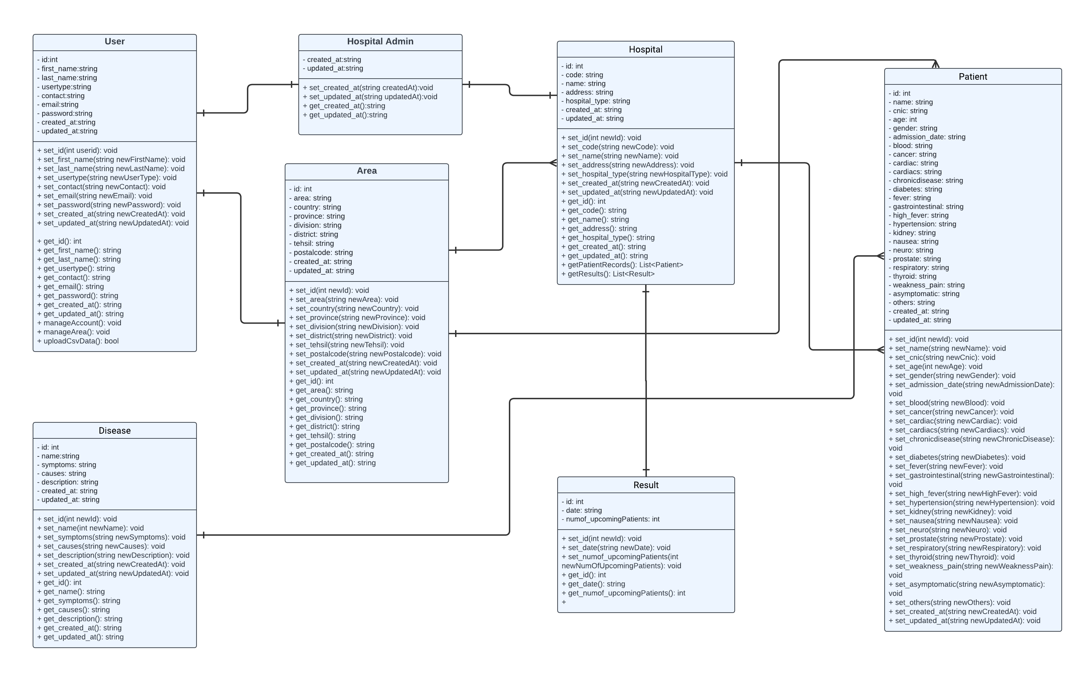
Figure 3.8.4.1: Abstract Class Diagram

Nonfunctional Requirements

Performance Requirements
As the system will be performing real-time descriptive and predictive analysis on big data. Therefore, the better performance of the system is a crucial factor.

Safety Requirements
Following are the safety requirements that should be considered:
- Implement role-based authentication mechanisms for user logins to prevent unauthorized access.
- Defining user roles and permissions to ensure users can only access confidential data and functionalities relevant to their role.
- Ensuring all patient data is handled by data protection laws and regulations.

Security Requirements
Our system deals with the clinical patient’s data. Therefore, the system will be secure enough to maintain data privacy. We will be ensuring that only authorized users can access the system and functionality according to their role.

Additional Software Quality Attributes
Following are Additional Software Quality Attributes which are given below:

Reliability
- The system should consistently provide accurate and timely analytics.
- The system should have a reliability rate of at least 99%, ensuring minimal disruption to analytics services.

Availability
- The system should be available 24/7 to ensure timely access to real-time analytics.
- System downtime should be kept to a minimum.

Security
- The system should protect sensitive healthcare data from unauthorized access.
- Role-based access controls with authorization should be implemented to ensure the system's security.

Usability
- The system should be easy to use and navigate for users.
- The Web portal design should be highly user-friendly, facilitating easy interaction and navigation for users.

Other Requirements

Hardware And Software Requirements
Following are the hardware and software requirements that are required to build and deploy our Project:

Hardware Requirements
- A server that should be available 24/7 that supports Apache Kafka, Apache Spark, ZooKeeper, and Postgres (for the database).
- Developing machines contain 16 GB RAM, Intel i5/i7/i9 8th generation or above processor or a similar processor and have decent GPU for machine learning.

Software Requirements
- NodeJS Environment (React)
- Apache Spark
- Apache Kafka
- Scala
- Apache Echart
- ZooKeeper
- PostgreSQL
- Java Development Kit (JDK)
- Web Browser

Revised Project Plan
We are on the same track.
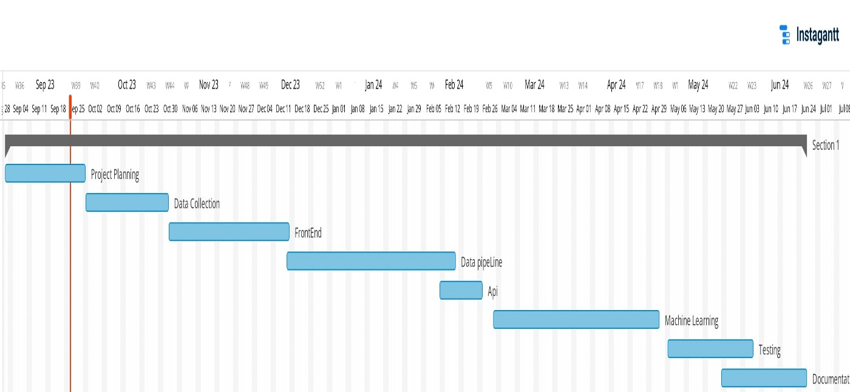.

References
- Basco, J. A., & Senthilkumar, N. C. (2017, November). Real-time analysis of healthcare using big data analytics. In IOP conference series: Materials science and engineering (Vol. 263, No. 4, p. 042056). IOP Publishing.
- Raghupathi, W., & Raghupathi, V. (2014). Big data analytics in healthcare: promise and potential. Health information science and systems, 2, 1-10.
- P. Kumar, “How Real-time Analytics improves outcomes in Health Care,” IBM 19 June 2017. [Online]. Available: https://www.ibm.com/cloud/blog/real-time-analytics-improves-outcomes-health-care/.
- Islam, M. S., Hasan, M. M., Wang, X., Germack, H. D., & Noor-E-Alam, M. (2018, May). A systematic review on healthcare analytics: application and theoretical perspective of data mining. In Healthcare (Vol. 6, No. 2, p. 54). MDPI.

Appendix A: Glossary
EMR: Electronic Medical Records
Electronic Medical Records (EMR) are the digital versions of patient’s paper charts. EMRs contain notes, medical history, diagnoses, medications, treatment plans, immunization dates, allergies, radiology images, and laboratory test results.
HDFS: Hadoop Distributed File System
HDFS stands for Hadoop Distributed File System is a distributed file system which is designed to store large amounts of data across multiple machines(nodes). It is a main core component of the Apache Hadoop.
RDD: Resilient Distributed Datasets
Resilient Distributed Datasets (RDD) is a fundamental data structure of Apache Spark, representing an immutable distributed collection of objects that can be processed in parallel.
API: Application Programming Interface
An Application Programming Interface (API) is a set of rules and tools for building software applications. It defines the methods and data formats that applications can use to communicate with each other.
MLlib: Machine Learning Library
MLlib is a machine learning library for Apache Spark. It provides various tools for machine learning tasks such as classification, regression, clustering, and collaborative filtering.
REST: Representational State Transfer
Representational State Transfer (REST) is an architectural style for designing networked applications. It uses a stateless communication model like HTTP allowing clients to request and manipulate resources on servers.
CSV: Comma-Separated Values
Comma-Separated Values (CSV) is a plain text file format that uses commas to separate values.
GPU: Graphics Processing Unit
A Graphics Processing Unit (GPU) is a specialized electronic circuit designed to accelerate the processing of images and videos. In machine learning, GPUs are used to speed up complex computations.
UI/UX: User Interface/User Experience
User Interface (UI) refers to the visual elements and interactive components with which user interact. User Experience (UX) encompasses the overall experience users have with the application, including usability, accessibility, and satisfaction.
Apache Kafka
Apache Kafka is a distributed streaming platform that allows for the creation of real-time data pipelines and streaming applications. It is used for building scalable and fault-tolerant systems.
Apache Spark
Apache Spark is an open-source distributed computing system that provides fast and general-purpose cluster computing for big data processing. It includes libraries for data analysis, machine learning, graph analysis, and more.
ZooKeeper
ZooKeeper is used in distributed systems which provide service synchronization and as a naming registry.

